*Date: 16/09/2024*

***Assignment 01***

*Name: MEHRIN FARZANA*

*ID: 2101013*

*Problem no. 1.*

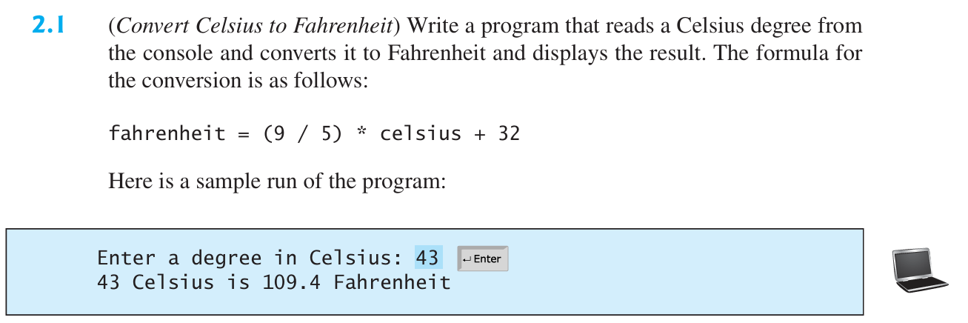

*Solution:*

Code:

cel = int(input("Enter a degree in Celsius: "))

far = round((9 / 5) * cel + 32, 2)

print(cel, end=" ")

print("Celcius is ", end="")

print(far, end=" ")

print("Fahrenheit")

Output:



Figure 1.1: Output

*Problem no. 2.*

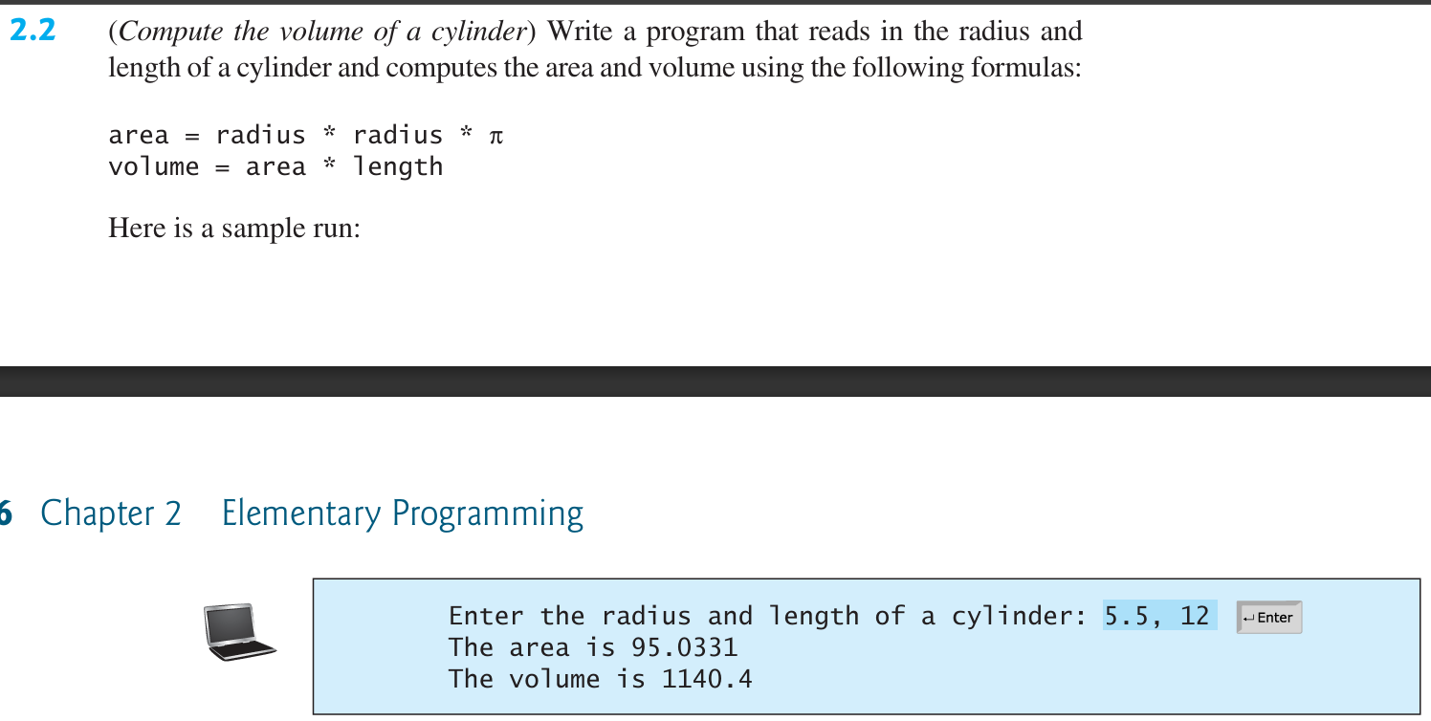

*Solution:*

Code:

import math

r, l = map(float, input("Enter the radius and length of a cylinder: ").split())

a = r * r * math.pi

v = a * l

print("The area is ", end="")

print(a)

print("The volume is ", end="")

print(v)

Output:

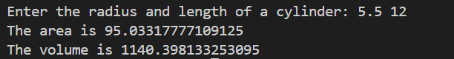

Figure 2.1: Output

*Problem no. 3.*

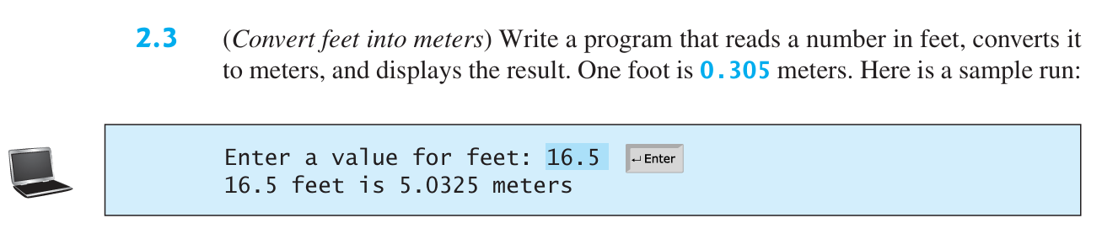

*Solution:*

Code:

feet = float(input("Enter a value for feet: "))

meter =  0.305 * feet

print(feet, end=" ")

print("feet is ", end="")

print(meter, end=" ")

print("meters")

Output:



Figure 3.1: Output

*Problem no. 4.*

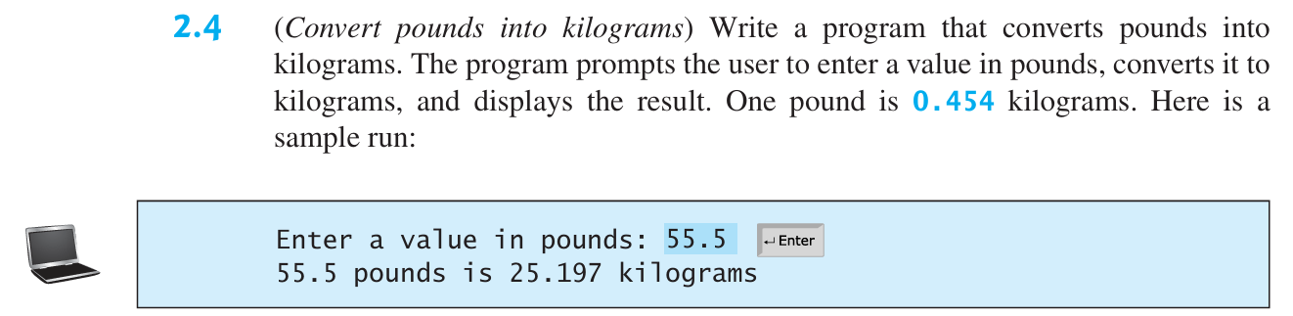

*Solution:*

Code:

pound = float(input("Enter a value in pounds: "))

kg =  0.454  * pound

print(pound, end=" ")

print("pounds is ", end="")

print(kg, end=" ")

print("kilograms")

Output:



Figure 4.1: Output

*Problem no. 5.*

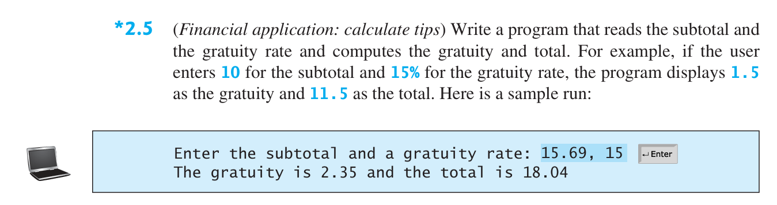

*Solution:*

Code:

subtotal, gratuityRate = map(float, input("Enter the subtotal and a gratuity rate: ").split(","))

gratuity = round(subtotal * gratuityRate / 100, 2)

total = round(subtotal + gratuity, 2)

print("The gratuity is ", end="")

print(gratuity, end=" ")

print("and the total is ", end="")

print(total)

Output:



Figure 5.1: Output

*Problem no. 6.*

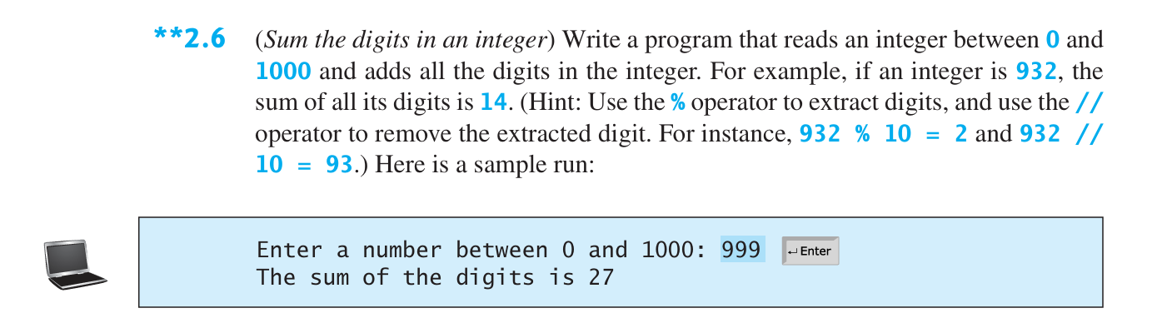

*Solution:*

Code:

n = float(input("Enter a number between 0 and 1000: "))

sum = 0

while(n>0):

    sum += n % 10

    n //= 10

print("The sum of the digits is ", end="")

print(int(sum))

Output:



Figure 6.1: Output

*Problem no. 7.*

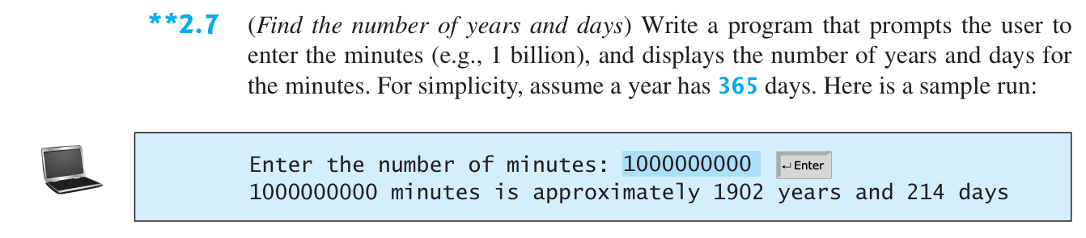

*Solution:*

Code:

m = float(input("Enter the number of minutes: "))

y = int(m / (60*24*365))

d = int((m % (60*24*365)) / (60*24))

print(m, end=" ")

print("minutes is approximately", end=" ")

print(y, end=" ")

print("years", end=" ")

print(d, end=" ")

print("days")

Output:



Figure 7.1: Output

*Problem no. 8.*

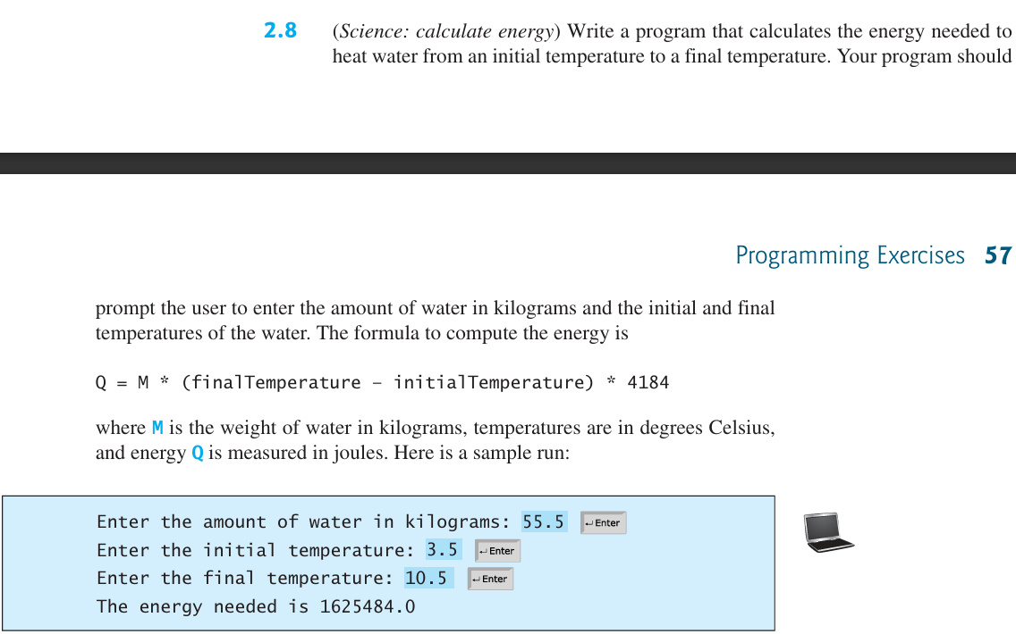



*Solution:*

Code:

w = float(input("Enter the amount of water in kilograms: "))

t1 = float(input("Enter the initial temperature: "))

t2 = float(input("Enter the final temperature: "))

e = w * (t2 - t1) * 4184

print("The energy needed is", end=" ")

print(e)

Output:

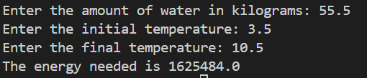

Figure 8.1: Output

*Problem no. 9.*

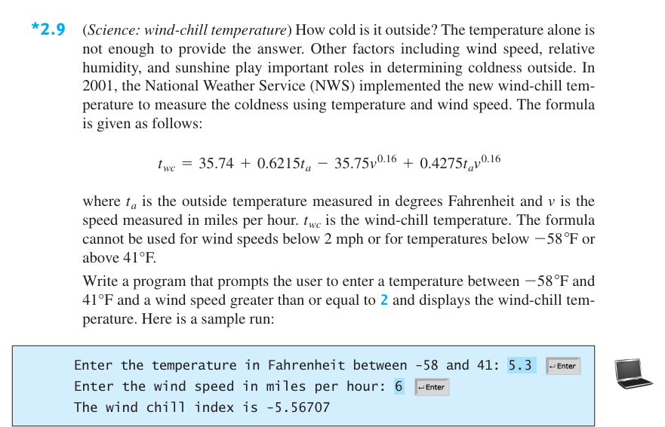

*Solution:*

Code:

t = float(input("Enter the temperature in Fahrenheit between -58 and 41: "))

v = float(input("Enter the wind speed in miles per hour: "))

c = round(35.74 + 0.6215*t - 35.75*(v**0.16) + 0.4275*t*(v**0.16), 5)

print("The wind chill index is", end=" ")

print(c)

Output:

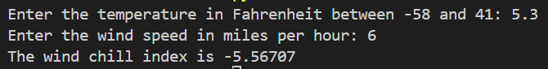

Figure 9.1: Output

*Problem no. 10.*

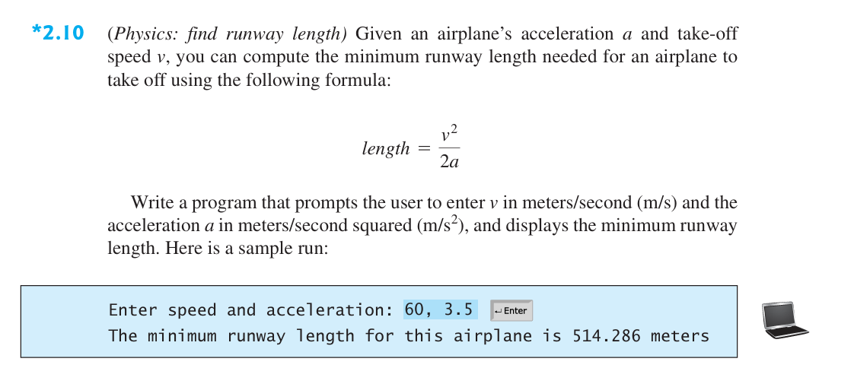

*Solution:*

Code:

v, a = map(float, input("Enter speed and acceleration: ").split(","))

l = round((v**2)/(2*a), 3)

print("The minimum runway length for this airplane is", end=" ")

print(l, end=" ")

print("meters")

Output:



Figure 10.1: Output

*Problem no. 11.*

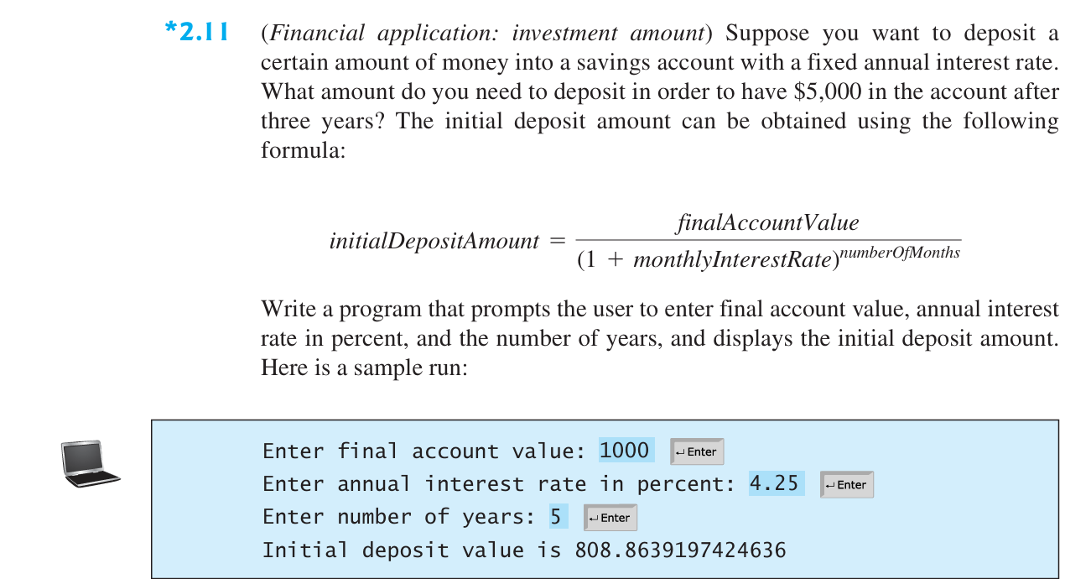

*Solution:*

Code:

a = float(input("Enter final account value: "))

r = float(input("Enter annual interest rate in percent: "))

y = float(input("Enter number of years: "))

d = a / ((1 + (r/100)) ** y)

print("Initial deposit value is", end=" ")

print(d)

Output:

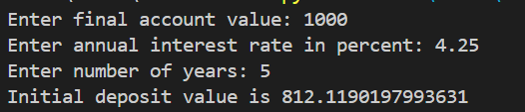

Figure 11.1: Output

*Problem no. 12.*

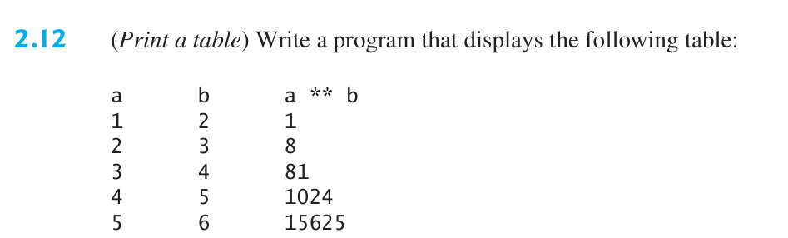

*Solution:*

Code:

print('a' , end="      ")

print("b" , end="      ")

print("a**b")

for i in range(1,6):

    print(i , end="      ")

    print(i+1 , end="      ")

    print(i**(i+1))

Output:

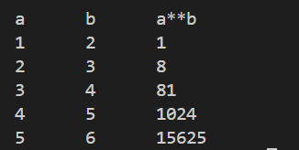

Figure 12.1: Output

*Problem no. 13.*

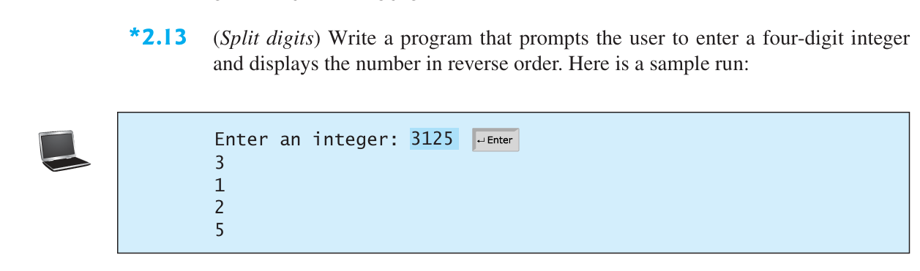

*Solution:*

Code:

n = int(input("Enter an integer: "))

d = 0

a = []

i = 0

while(n>0):

 a.append(n%10)

 n //=10

 i += 1

while(i != 0):

    print(a[i-1])

    i -= 1

Output:

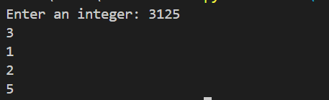

Figure 13.1: Output

*Problem no. 14.*

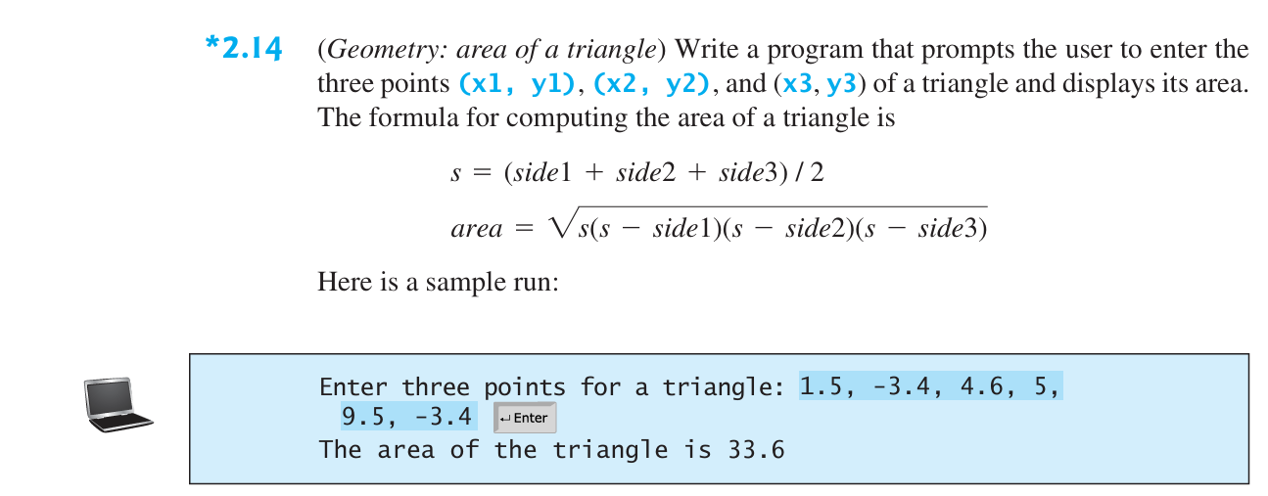

*Solution:*

Code:

import math

x1, y1, x2, y2, x3, y3 = map(float, input("Enter three points for a triangle: ").split(","))

side1 = math.sqrt(((x1-x2)**2) + ((y1-y2)**2))

side2 = math.sqrt(((x3-x2)**2) + ((y3-y2)**2))

side3 = math.sqrt(((x1-x3)**2) + ((y1-y3)**2))

s = (side1 + side2 + side3) / 2

a = round(math.sqrt(s*(s- side1)*(s- side2)*(s- side3)), 1)

print("The area of the triangle is", end=" ")

print(a)

Output:



Figure 14.1: Output

*Problem no. 15.*

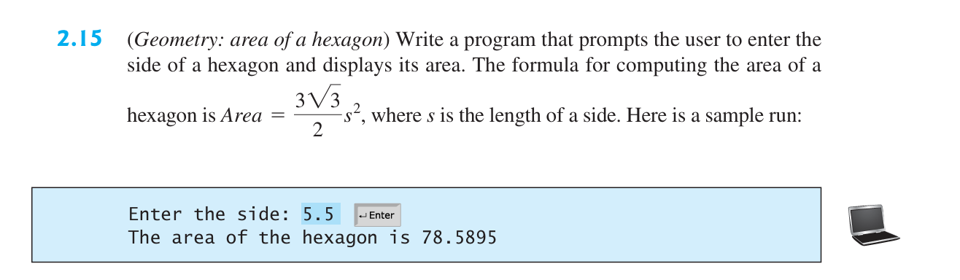

*Solution:*

Code:

import math

s = float(input("Enter the side: "))

a = round((3*math.sqrt(3)*(s**2))/2, 4)

print("The area of the hexagon is", end=" ")

print(a)

Output:



Figure 15.1: Output

*Problem no. 16.*

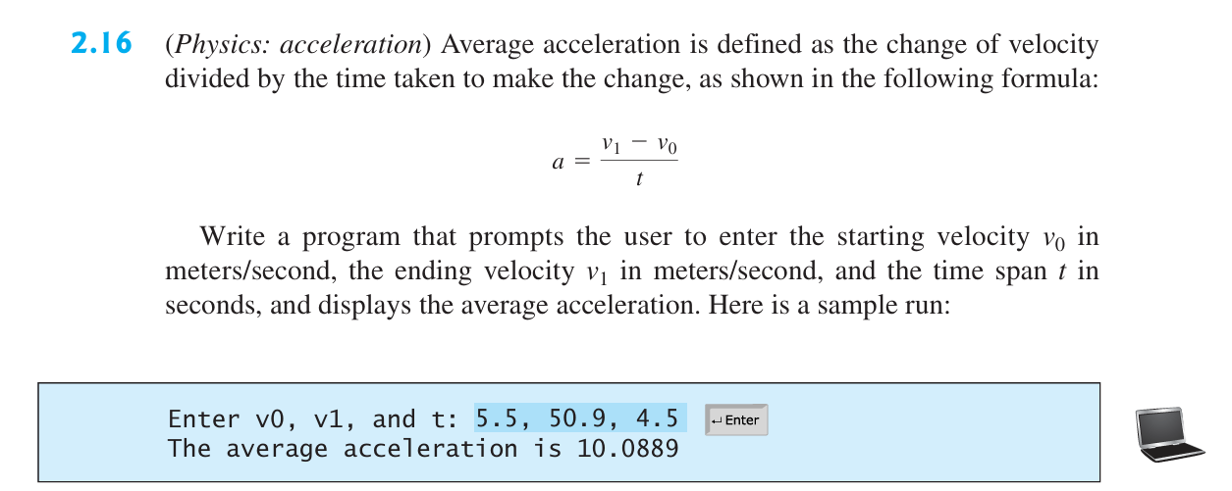

*Solution:*

Code:

v0, v1, t = map(float, input("Enter v0, v1, and t: "). split(","))

a = round((v1-v0)/t, 4)

print("The average acceleration is", end=" ")

print(a)

Output:



Figure 16.1: Output

*Problem no. 17.*

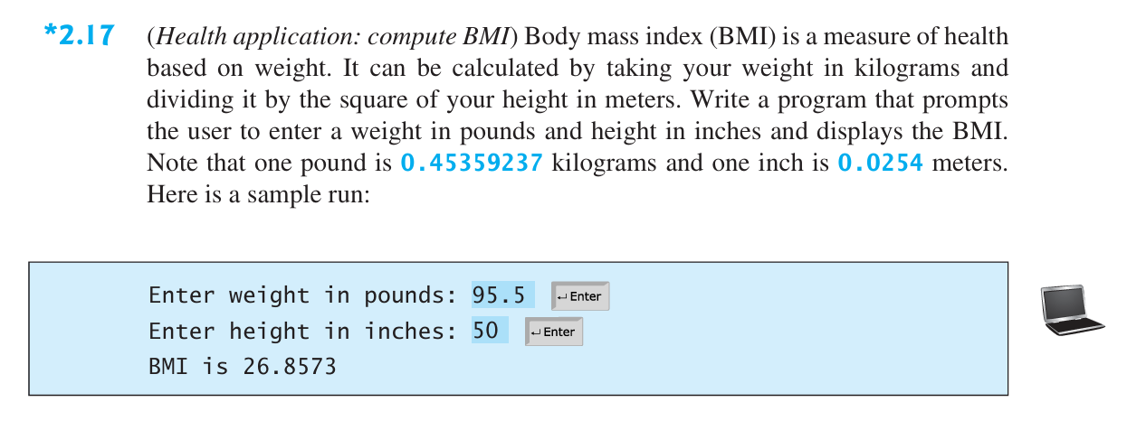

*Solution:*

Code:

w = float(input("Enter weight in pounds: ")) * 0.45359237

h = float(input("Enter height in inches: ")) * 0.0254

bmi = round(w / (h ** 2), 4)

print("BMI is", end=" ")

print(bmi)

Output:

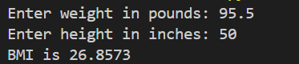

Figure 17.1: Output

*Problem no. 18.*

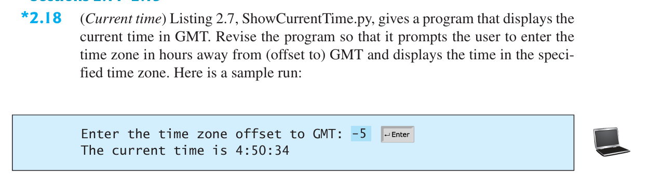

*Solution:*

Code:

import time

offset = int(input("Enter the time zone offset to GMT: "))

current_time = time.time()

total_seconds = int(current_time)

current_second = total_seconds % 60

total_minutes = total_seconds // 60

current_minute = total_minutes % 60

total_hours = total_minutes // 60

current_hour = total_hours % 24

current_hour = (current_hour + offset) % 24

print(f"The current time is {current_hour:02}:{current_minute:02}:{current_second:02}")

Output:

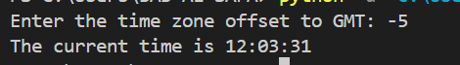

Figure 18.1: Output

*Problem no. 19.*

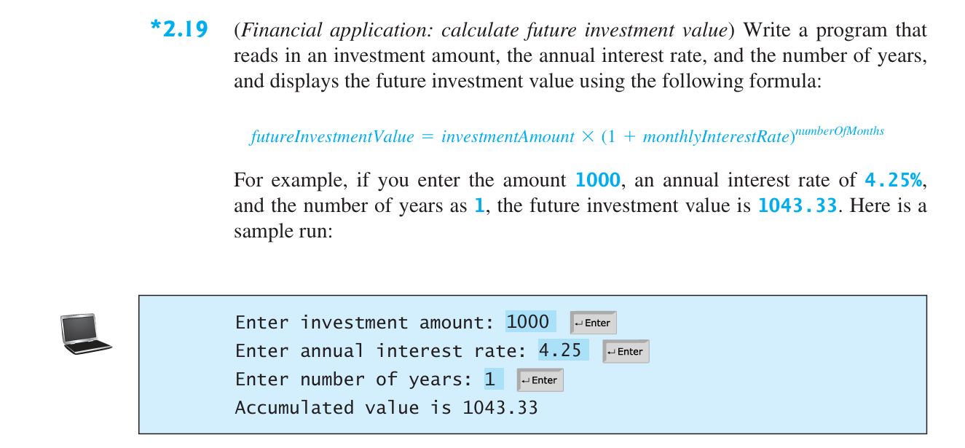

*Solution:*

Code:

i = float(input("Enter investment amount: "))

r = float(input("Enter annual interest rate: ")) / 100

y = float(input("Enter number of years: "))

a = round( i * (1 + r)**y, 2)

print("Accumulated value is", end=" ")

print(a)

Output:

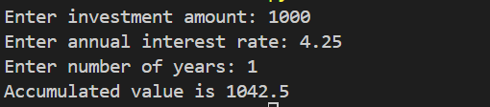

Figure 19.1: Output

*Problem no. 20.*

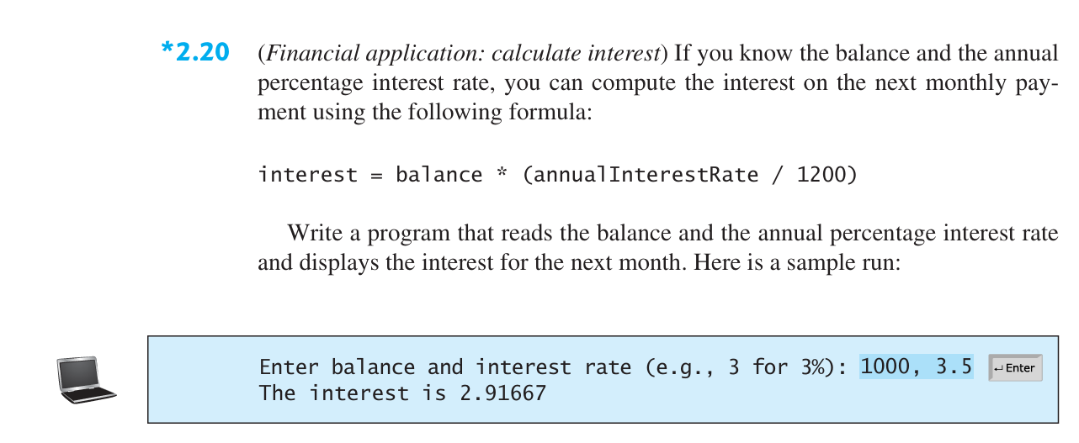

*Solution:*

Code:

b, r = map(float, input("Enter balance and interest rate (e.g., 3 for 3%): ").split(","))

i = round(b * (r / 1200), 5)

print("The interest is", end=" ")

print(i)

Output:



Figure 20.1: Output

*Problem no. 21.*

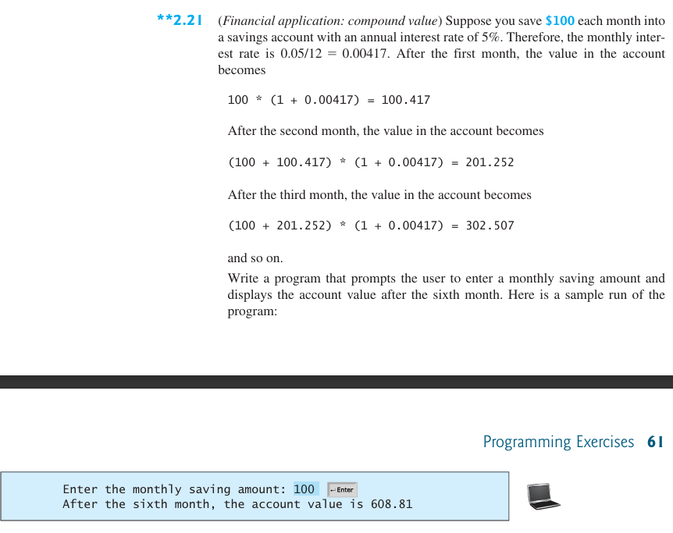

*Solution:*

Code:

s = float(input("Enter the monthly saving amount: "))

a = 0

for i in range(6):

    a = (a+s)*(1+(0.05/12))

print("After the sixth month, the account value is", end=" ")

print(round(a, 2))

Output:



Figure 21.1: Output

*Problem no. 22.*

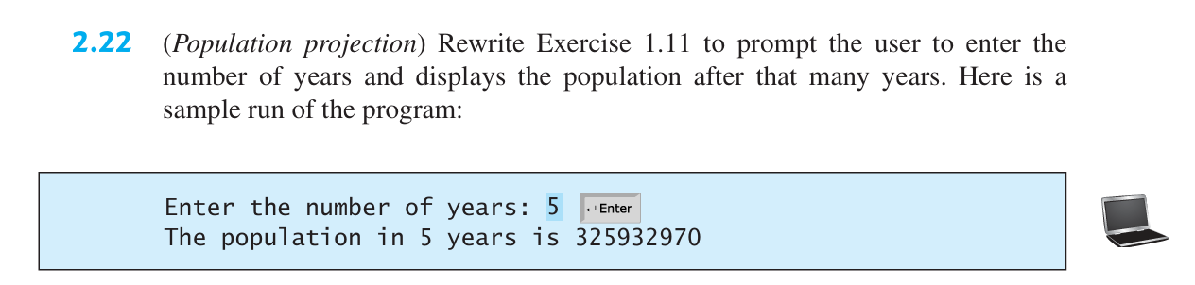

*Solution:*

Code:

y = int(input("Enter the number of years: "))

cp = 312032486

s = y*60*60*24*365

p = cp + (s//7) - (s//13) + (s//45)

print("The population in", end=" ")

print("y", end=" ")

print("years is", end=" ")

print(p)

Output:



Figure 22.1: Output

*Problem no. 23.*

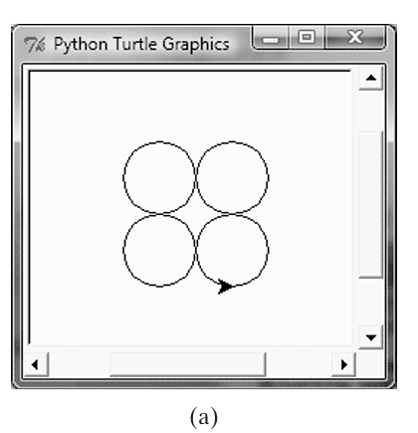

*Solution:*

Code:

import turtle

radius = float(input("Enter the radius for the circles: "))

turtle.penup()

positions = [(-radius, radius), (radius, radius), (-radius, -radius), (radius, -radius)]

for pos in positions:

    turtle.goto(pos)

    turtle.pendown()

    turtle.circle(radius)

    turtle.penup()

turtle.done()

Output:

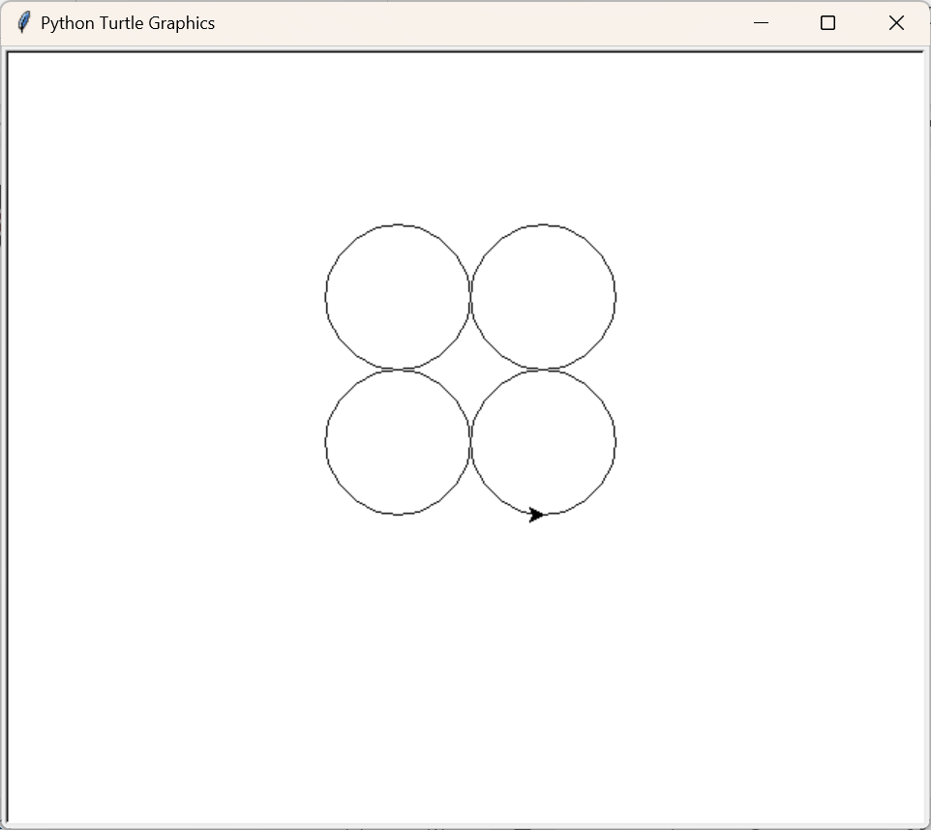

Figure 23.1: Output